Chi Alpha Mu National Junior High Mathematics Honor Society
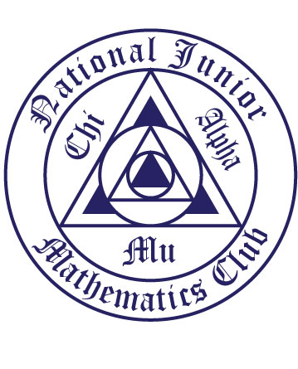
Teacher Recommendation

Student Name __________________________________________Grade ________
(Print first and last name neatly)

Teacher Name ___________________________________________________

Please rank the student in the following categories:
0 is non-existent … 5 is highest

Please comment on any ranking under a 3.

Integrity:
0 1 2 3 4 5
Comment:
Scholarship:
0 1 2 3 4 5
Comment:
Leadership:
0 1 2 3 4 5
Comment:
Ability to work with others:
0 1 2 3 4 5
Comment:

Teacher Signature ____________________________________ Date ________

Please return to Mrs. Heun directly or in her mail-box.
Thank you for your input!

